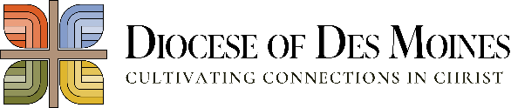
2026 Impact Facts
Clergy Care and Vocations (includes health care and retirement)
- 43 active priests with medical and insurance provided exclusively by the Diocese
- 43 retired priests with medical care and retirement income
- 31 international priests with U.S. citizenship and immigration services
- 14 seminarians with formation and tuition expenses
- 107 active and retired deacons with training, education and support
- 18 men in diaconate formation with scheduled ordination of September 2028

Catholic Formation and Education
- 6,926 Children receive a holistic education in our Catholic schools
- 16 Catholic Schools with professional training, supervision and oversight
- 611 Catholic School Teachers
- 7,764 Children encounter Christ in parish faith formation
- 1,151 Catechists and Youth Ministers
- 1,620 New members of the faith through Baptism
- 1,599 Communicants received the Body and Blood of Christ for the first time
- 1,499 Confirmands sealed with the gifts of the Holy Spirit

Ministries and Worship
- More than 40,000 Hispanic, Vietnamese, Burmese and various other Catholics with cultural outreach ministry needs
- 4 Catholic hospitals offering Mass, Communion and Anointing of the Sick
- 400 Individuals undergoing marriage preparation
- 40 Active youth ministries
- Active Young Adult programs and Young Catholic Network
- Disability Ministry providing ASL interpreting services, adaptive resources, Disability Ministry training and adaptive formation resources

Parish Services and Administration
- Bishop's Office and support
- 5,365 employees and volunteers undergo screening ad training to ensure a safe environment for our children
- 2031 Employees, 1089 with managed benefit plans
- 79 parishes across 23 counties with ministry and administrative services
- 33,572 Households receiving The Catholic Mirror via print, electronically and e-newsletter

Catholic Charities and other Needs
- More than 35,000 served through Catholic Charities – food pantries, refuge, domestic violence, counseling, shelters and more

